**Compound Pattern:**

1. Definition: A compound pattern combines two or more patterns to solve a recurring general problem.
2. Different design pattern can work together.

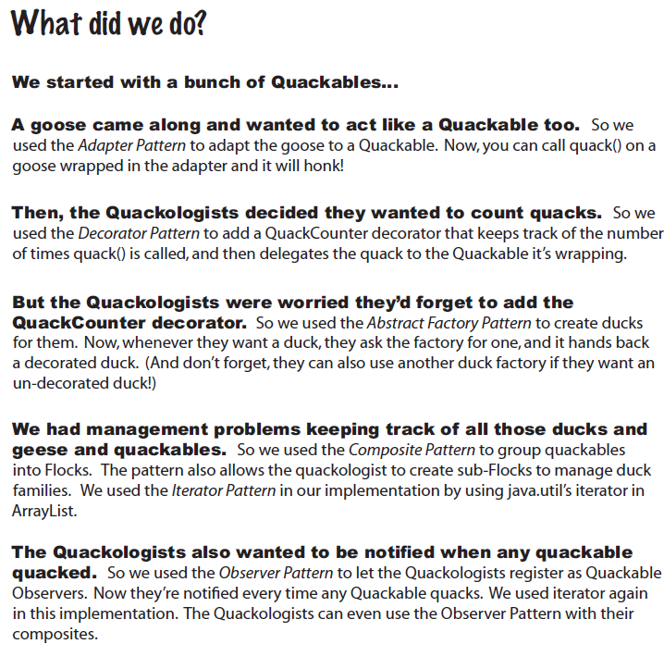

1. **MVC compound pattern:**